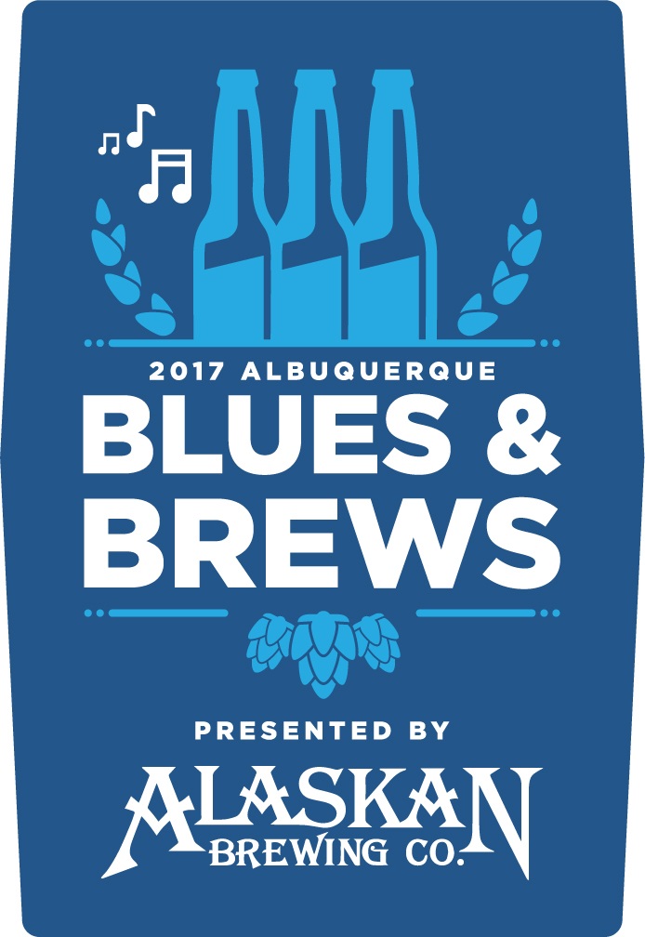
Information Sheet
7th Annual Albuquerque Blues & Brews Presented by Alaskan Brewing Co.
70 Breweries, 5 Blues Bands & 4 Hours Beer Sampling
When: Sunday, May 28th 2p-6p (Memorial Day Weekend) Doors open 30 minutes prior for ID checks
Where: Sandia Resort & Casino
Ticket Types:
VIP ADMISSION
4 hours of sampling 2p-6p, gates open 1:30p
Get first taste of great brews plus access to the VIP Lounge with this exclusive, very limited admittance ticket
Paid Admission includes: VIP Lounge access with food & beer, Early Access entrance to festival, music, vendors, games, unlimited 2-ounce beer samples, souvenir tasting glass, event program and entrance to our Grand Prize Drawing. 21+ only
$55 - Pre-Sale / $60 - Regular Advanced Tickets / $65 - Day of Tickets (while supplies last)
*plus tax and applicable credit card fees
VIP Tickets available only while supplies last. Please note that demand for VIP tickets is high and availability is very limited.

EARLY ACCESS ADMISSION
4 hours of sampling 2p-6p, gates open 1:30p
Get first taste of great brews with this exclusive, limited admittance hour
Paid Admission includes: Early Access entrance to festival, music, vendors, games, unlimited 2-ounce beer samples, souvenir tasting glass, event program and entrance to our Grand Prize Drawing. 21+ only
$35 - Pre-Sale Advanced Tickets / $40 - Regular Advanced Tickets / $45 - Day of Tickets (while supplies last)
*plus tax and applicable credit card fees
Early Access Tickets available only while supplies last. Please note that demand for Early Access tickets is high and availability is limited. We have sold out every year and expect to sell out quickly.

GENERAL ADMISSION
3 hours of sampling 3p-6p, gates open 2:30p
Paid Admission includes: entrance to festival, music, vendors, games, unlimited 2-ounce beer samples, souvenir tasting glass, event program and entrance to our Grand Prize Drawing. 21+ only
$25- Pre-Sale Advanced Tickets / $30 - Regular Advanced Tickets / $35 - Day of Tickets (while supplies last) *plus tax and applicable credit card fees
Tickets sold out last year, so please purchase your tickets in advance to ensure entrance.
NON SAMPLING TICKET
2p-6p, gates open 1:30p
Paid Admission includes entrance to festival, music, vendors and games. One bottle of water for first 100 ticket holders. 21+ only
$10 - while supplies last
*plus tax and applicable fees
LAST DAY TO GET PRE-SALE ADVANCE TICKETS: Friday, April 28
LAST DAY TO GET REGULAR ADVANCE TICKETS: Saturday, May 28
Buy tickets at HoldMyTicket.com or Tractor Brewing Co.
Website – www.abqbluesandbrews.com

